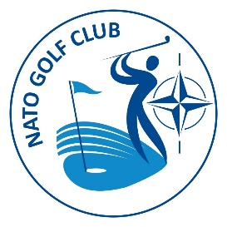
NATO GOLF CLUB Property Manager Report 2023

SUMMARY

Two main areas require the attention of the property manager:
- The SHOP
- TROPHIES and other items
This was a year of continuity, with no major decisions on the way forward in regard to the shop. The main concern was the restock of Club trophies, which has been done.
Depending on the decisions left for the new NATO Golf Club EC, there is a need to rethink the strategies for the shop and, from there, proceed with the restock.
The property manager only deals with the goods. All the financial transactions are responsibility of the treasurer.

The Shop
The shop is active and accessible online @ https://www.natogolfclub.org/shop . The shop doesn’t offer shipping. Pick up of items are arranged directly between buyers and the property manager. The delivery of items should be done, preferably, during club events.
The shop remains its exclusive objectives of promoting NGC by making available to members and friends a variety of items with our logo and allowing to access, in a very handy way, to some great golf products.
There weren’t many sales during this report period. There was no aggressive campaign to promote the shop and that was not assessed as a key priority during this period. New memberships and the expectations of a new team on the steering wheel give us a good reason for optimism on the coming months!
Inventory of the existing items in the shop is presented in Annex A.

TROPHIES AND ITEMS
Early this year we had to proceed with the purchase of the trophies for the season, and we decided to go with two years horizon to ease the process for the new EC. Once the previous seller was already in possession of our vectorized logos and had the models prepared, we decided to buy from him, although he is based in the UK, and therefore, subject to additional taxation.
With exemption of the Celtic Quaich and the Presidents Cup, all the other Posie Bowls are in sufficient number to cover next season. It is advised, however, to anticipate next orders in due time.
All the exchange of emails were done from the shop@natogolfclub.org email, which will facilitate the handover for the new responsible for this ares within the EC.
The inventory of the trophies / other items is presented in Annex A.

The Property Manager
Ricardo Guerreiro

