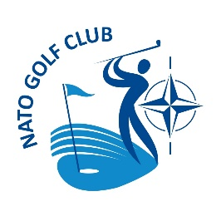
Treasurer’s Report for the Year 2022
25 April 2023

Summary
- The NATO Golf Club (NGC) remained financially healthy in 2022. The balance in the Club’s bank account at the end of the year was €6,404.89, a decrease of €25.86 over the year. A summary of NGC’s actually Income and Expenditures, compared to the approved 2022 budget, will be provided separately. In light of our continuing positive financial situation, your Committee recommends that annual membership fees for 2023 remain at €40 for Regular and Associate Members and €25 for Overseas Members.
Club Activities
- For the historical record, a table of Club activities in 2022 is provided at Annex 2.
Proposed Budget
- The proposed NGC budget for 2023 is attached as Annex 1. Approval of this budget will be sought at the Annual General Meeting on 25 April 2023.
Membership
- At the end of 2022, we had 28 paid members (15 Regular, 11 Associate, 2 Overseas). This is a drop of 2 from 2021, when the numbers were 16 R, 13 A and 4 O. The use of the automatic subscription renewal and self-determination of membership category by the applicant, while very convenient, adds complexity to tracking club membership. This will be addressed by the Executive Committee in 2023.
Club Property
- Our Property Manager, Ricardo Guerreiro has submitted his report, including lists of the current holdings of kit, trophies and other material used for publicity or conduct of competitions. To have a true value of the assets of the Club, the value of the stock on hand for sale, will in the future be reported as assets of the NATO Golf Club. The trophies, posy balls and paperweights have little or no value, if sold, so will listed but do not contribute to the Clubs financial status.
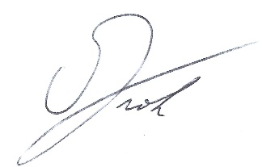

Rick Froh
Treasurer
Annex 1

PROPOSED NGC BUDGET FOR 2023
Serial | Description | Assets € | Liabilities €
1 | Starting Balance 1 January 2023 | 6,404.89
2 | Annual Membership Fees (30x R&A) + (5x O) | 1,325.00
3 | Sale of Logo Kit | 100.00
4 | Bank interest | 0.00
5 | Total Income | 1,425.00
6 | Bank Charges |  | 80.00
7 | Prizes – Posy Cups for Club Championship events in 2023-2025 NGC Seasons, including shipping and customs duties |  | 1,500.00
8 | IT Support (WIX site, domain name) |  | 800.00
9 | Trophies (maintenance, purchases) |  | 50.00
10 | AGM Drinks (20 pers @ 20€ each) |  | 400.00
11 | France Trip Subsidy (tbc) |  | 0.00
12 | Purchase New Logo Kit |  | 1,000.00
13 | Miscellaneous (flowers, cards, stationary) |  | 100.00
14 | Total Expenses |  | 3,930.00
16 | Expected Profit/Loss |  | 2,505.00
15 | Expected Balance 31 December 2023 | 3,899.89

Annex 2

NGC EVENTS IN 2022

Serial | Date | Event | Location/Courses
1 | 23 January | Celtic Quaich | Brabastse
2 | 12 February | St Valentine Massacre | Falnuee
3 | 13 March | Friendly | Winge
4 | 8 May | President’s Cup | Louvain-la-Neuve
5 | 8 May | Annual General Meeting | Louvain-la-Neuve
6 | 14 May | Captain’s Cup | L'Empereur
7 | 4 June | Club Championships | La Tournette – American
8 | 19 June | Closing/NATO Cup | Pierpont
7 | 16 July | Friendly | Rigenée
8 | 11 September | Opening/Barry Carr Cup | Pierpont
9 | 8 October | Friendly | Mont Garni
10 | 22 October | NGC-IGC Match | Winge
11 | 5 November | Friendly | Mont Garni
12 | 3 December | Christmas Cracker | Rigenée
Non-Club Events
 | 25 March – 2 April | 19th Turkey Away Trip | Belek - `Noblis, Pasha, Gloria/ Old
 | 1 July | ADIF | Sept Fontaines

Includes cost of international bank transfers to UK and USA

